Nama : I Putu Krisna Dharma Saputra

NIM : 2301924353

**Diketahui :**

Marketing Division : Need 4 host

Research Division : Need 19 host

Programer Division : Need 7 host

NA (Network Address) = 103.49.221.0

SM (Subnet Mask) = 24

= 11111111.11111111.11111111.00000000

= 255.255.255.0 -> class C

1. Urutkan jaringan berdasarkan kebutuhan host dari yang tertinggi ke terendah

- Research Division : 19 host

- Programmer Division : 7 host

- Marketing Division : 4 host

2. Tentukan Subnet Mask baru, Network Prefix baru, dan Total Host untuk setiap jaringan

Formula: 2^h – 2 >= total host each division

* **Research Division**

2^h – 2 >= 19

2^5 – 2 >= 19

32 – 2 >= 19

30 >= 19

h = 5

Formula: n = 32 – b – h

b = total bit 1 from old subnet mask

n = 32 – 24 – 5 = 3

New Subnet Mask = 11111111.11111111.11111111.**111**00000

= 255.255.255.224

**New network prefix = /27**

Total host = 2^h

= 2^5

= **32 hosts**

* **Programmer Division**

2^h – 2 >= 7

2^4 – 2 >= 7

16 – 2 >= 7

14 >= 7

h = 4

n = 32 – b – h

b = total bit 1 from old subnet mask

n = 32 – 24 – 4 = 4

New Subnet Mask = 11111111.11111111.11111111.**11110**000

= 255.255.255.240

**New network prefix = /28**

Total host = 2^h

= 2^4

= **16 hosts**

* **Marketing Division**

2^h – 2 >= 4

2^3 – 2 >= 4

8 – 2 >= 4

6 >= 4

h = 3

n = 32 – b – h

b = total bit 1 from old subnet mask

n = 32 – 24 – 3 = 5

New Subnet Mask = 11111111.11111111.11111111.**11111**000

= 255.255.255.248

**New network prefix = /29**

Total host = 2^h

= 2^3

= **8 hosts**

3. Tentukan masing-masing IP Address setiap divisi

- IP address range for Research Division:

• 103.49.221.1/27 -> Network Address

• 103.49.221.2/27 – 103.49.221.30/27 -> Usable IP Address

• 103.49.221.31/27 -> Broadcast Address

- IP address range for Programmer Division:

• 103.49.221.32/28 -> Network Address

• 103.49.221.33/28 – 103.49.221.46/28 -> Usable IP Address

• 103.49.221.47/28 -> Broadcast Address

- IP address range for Marketing Division:

• 103.49.221.47/29 -> Network Address

• 103.49.221.48/29 – 103.49.221.53/27 -> Usable IP Address

• 103.49.221.54/29 -> Broadcast Address

4. Diagram Jaringan di PT Kadit Osi

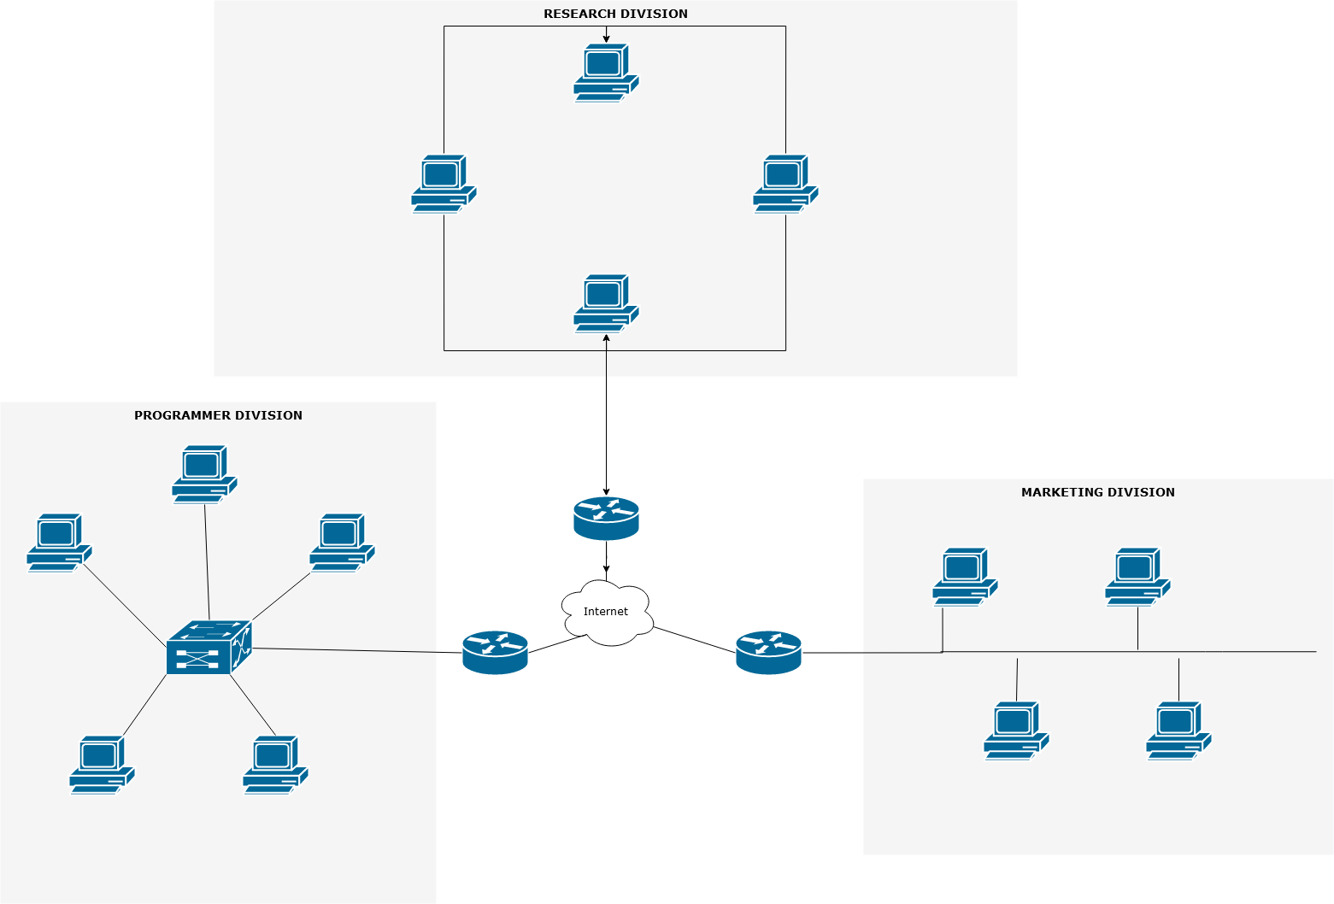

103.49.221.32/28

MAR 3 103.49.221.50/29

MAR 4 103.49.221.51/29

MAR 2 103.49.221.49/29

MAR 1 103.49.221.48/29

PRO 5 103.49.221.37/28

PRO 4 103.49.221.36/28

PRO3 2103.49.221.35/28

PRO 1 103.49.221.33/28

PRO 2 103.49.221.34/28

RES 4 103.49.221.5/27

RES 2 103.49.221.3/27

RES 1 103.49.221.2/27

RES 3 103.49.221.4/27

103.49.221.1/27

103.49.221.47/29